Analysis of solar streetlights for improved energy access in temporary settlements
J. D. Nixon^{a*}, K. Bhargava and E. Gaura (subject to change)
ª Coventry University, Faculty of Engineering, Environment and Computing, Coventry, CV1 2JH, UK
*corresponding author, E-mail: jonathan.nixon@coventry.ac.uk

Abstract
This paper examines how the performance of solar streetlight interventions can be improved. Solar streetlights fitted with ground-level AC sockets were deployed and monitored in two displaced settlements: a refugee camp in Rwanda and a temporary settlement in Nepal. Internally displaced settlements and refugee camps are settings that often lack street lighting or more generally electricity. Solar streetlights are becoming the norm in many geographies across the world due to bbb. We hypothesized that, given off-grid solar streetlights produce surplus energy, this could be made available to improve system performance and provide further energy access to refugees and displaced population in camps. We recognize however that solar streetlight performance and longevity have typically been poor in these types of remote settings and attempt to understand some of the technical leading factors for their mis-performance. To investigate the impact socket usage had on solar streetlight performance, we used X data processing method(s) to determine capacity losses and capacity shortages, that would have otherwise been undetected due to X missing data. Component reliability and implementation of LED drivers and inverters were the major issues encountered at both installation sites (across the 11 streetlights installed), reducing anticipated (at design stage) performance ratios from X-X% to X-X%, respectively in Rwanda and Nepal. Socket usage was X low, for X reasons… To guide future solar streetlight interventions, the challenges of deploying this type of system in protracted camp settings are outlined and the barriers to engaging communities in using the additional energy are identified to... Remedial actions at both sites included replacing lights and converts, and the potential additional energy that needed to be used to minimise surplus energy was identified (to be…, meaning…).
Keywords: Humanitarian aid; energy; PV; off-grid; missing data/data imputation; decentralised…

- Introduction

- Set the scene for the need for street lighting in camps, the impact of a lack of lighting, current situation of on and off grid street lighting. Extend to the current use of energy systems used for lighting more widely in refugee camps.
- Establish potential for doing more solar streetlights - Potential of surplus energy
- Outline RQs
- Highlight challenges/success of solar energy system and streetlight interventions in humanitarian context that have gone beyond regular solar streetlighting. Add paragraph relating to each RQ on technical performance, surplus energy and design/monitoring.
- Define aim of paper, showing how our aim/research questions are original, important and address a gap in knowledge

Solar streetlights can provide affordable lighting in remote locations were a grid connection is not possible. Lighting is particularly important in rural villages and refugee camps to improve safety, security and mobility [refs] and can offer environmental benefits in comparison to grid-connected lights (Tannous et al., 2018). However, the reliability of photovoltaic (PV) battery systems in these types of locations has often been poor [ref], meaning these benefits are not actually being realised in practice [ref]. Moreover, in off-grid solar systems, surplus solar energy is lost when there is no demand or it cannot be stored; this is known as a capture loss, which reduces the system’s overall efficiency [ref].
Numerous solar streetlight interventions in refugee camps and displaced settlements have failed: vandalism and theft are often cited as the main cause of the problems [ref]. Evidence suggests this occurs as a result of poor performance from the onset of installation – due to a lack of technical understanding of solar streetlights (e.g. on their reliability and maintenance needs), access to replacement parts, ownership, funds for basic maintenance and local skills for maintenance [ref]. Reliability of decentralised solar streetlights is an even greater problem for locations with highly variable seasons (e.g. monsoon season) and that are further from the equator (Lagorse et al., 2009). Whilst the issue of long-term reliability and performance is an issue for all PV installations (e.g. premature battery failure and rapid PV degradation) [refs], the majority of studies in the literature have focused on decentralised micro-grids or solar home systems [refs], rather than solar streetlights. The research here, therefore, set out to answer the following research questions:
Q1: What can be learnt from deploying solar streetlights in displaced settlements that will enhance the technical success of future interventions in protracted settings?
Q2: Can solar streetlight performance be improved by providing communities with access to surplus energy at the lights and does demand balance supply?
Q3: How accurate were the assumptions made to design and size the solar streetlight? (Do we want a similar question to the other solar paper 5?)

Research on the performance of solar streetlights in remote settings is limited, however several authors have identified that there are significant challenges that require further investigation. In Nigeria, the performance ratio (PR), which provides an indication of a solar system’s utilisation, ranged from 70-89% over 3 years when examining 36 solar streetlights. The same authors studied the reliability of these lights, findings that only 68% worked at the outset of installation due to faulty batteries and charge controllers, poor cabling and LED light issues (Fashina et al., 2017). Dust has been a major issue for solar streetlights in the Sahel region (Kama et al., 2017), highlighting a lack of basic maintenance. In Mandi and Kamand, India, solar streetlights were reported to suffer from frequent power cuts with the majority failing within 1-2 years. The communities reported that the lights were never officially maintained by the relevant municipal authorities (McMorran et al., 2016).
Due to diurnal and seasonal irradiance variations, the capture losses in decentralised solar streetlights are expected to range between 5-30% [ref]. Panguloori et al. (2013) suggested that this surplus is not enough to meet local energy needs, thus the authors investigated the potential efficiency gains that can be achieved by connecting streetlights to a centralised station, with surplus energy distributed for power to rural communities in remote areas of India (findings..?).
The energy demands in refugee camps are expected to be low with the majority of refugees owning few electronic devices - predominatly mobile phones. Several authors have also highlighted the potential benefit of even small quantities of electricity available from solar streetlights installed in remote locations. Lighting in remote poor areas can improve safety, particularly for women, and enable attendance at community activities, whilst the excess energy available could be used for radios, phones and TV, which would aid in connecting these locations to the outside world. However, simple solar home systems often require DC appliances that are not easily available (Millinger et al., 2012). An intervention by Digicel was attempted in Haiti were solar streetlights were fitted with sockets for phone and battery charging (Bellanca, 2014). However, the motivation was to increase customer usage of phones and service packages. The charging stations were initially free to use, but when the charging stations had no operator, clients preferred to pay to charge their phones somewhere else where they could be kept safe. Subsequent systems were installed by phone kiosks and run by entrepreneurs with profits of around 100-150 USD/month; around 400 stations were established by Digicel in Haiti.
As standalone PV-battery solar streetlights will not receive a reliable source of solar energy all year round, appropriate sizing and selection of components is needed to minimise potential capacity shortages. Oladeji et al. (2015) demonstrated the process of designing a solar streetlight for Ilorin, Nigeria, supported by simulations using HOMER. A number of alternative designs have also been investigated by other authors to improve reliability and reduce storage requirements and costs. Nyemba et al. (2019) outlined a wind-PV solar streetlight design for Zimbabwe, suggesting battery capacity could be reduced by 40% and (Lagorse et al., 2009) optimised a hybrid fuel cell-PV design using genetic and simplex algorithms. However, these systems were not implemented and monitored to see if the simulated gains in performance could actually be realised in practice.
The aim of our research was to design, implement and monitor the performance of smart solar streetlight deployed in displaced settlements that provide additional energy access and to see if anticipated performance was realised in practice. The systems were designed and deployed in two different settings as outlined in section 2, with the data collection and processing techniques used to analyses the systems detailed in section X. The performance analysis results are provided in section 3 and a discussion in response to each research question is provided in section 4.

- Method and materials

- Context of HEED project
- Outline of research, surveys and workshops to arrive at solar system interventions
- Location of interventions
- System specifications, components and design.
- Justify and define how the systems will be monitored
- Details on data collection equipment and processing techniques including issues/processing of missing data/yield. Needs careful thought given the poor data we have and depends on RQs.
- Define and provide rationale for results to be obtained/analysed

The research methods reported here were carried out for the Humanitarian Engineering and Energy for Displacement HEED research project (EP/P029531/1), in the period 01/09/2017-31/05/2020. The HEED programme aimed to deliver energy access and evidence on humanitarian energy to: understand how available energy devices are used to influence future designs; promote and measure collaborative use of energy for common goals and economic growth; measure improved perception of safety through communal energy devices, and deliver an evidence base on the usage and utility of energy devices to inform energy policy in displaced settings.
To build an evidence base on the value and benefits for humanitarian energy provisions, the HEED project worked with displaced communities in three refugee camps in Rwanda (Kigeme, Nyabiheke, Gihembe refugee camps) and four temporary settlements in Nepal (Uttargaya and Bhogate Tar in the Rasuwa District, and Indreni Chaur and Battarin the Nuwakot district). To determine the exact sites for deploying a number of monitored energy interventions, site assessments, baseline surveys of current energy practices and community co-design workshops were carried out. One of the outcomes from this work was the need for smart solar streetlights with additional energy access provided by ground-level AC sockets. The rationale for the intervention was:
- To enable building an evidence base on value and benefits for streetlights that can influence policy.
- To identify best practice in the construction, location and security measures for long-lived street lighting.
- To understand how communities would use a shared energy resource when available, auxiliary to the main function of the streetlights (e.g. outdoor sockets for teaching, hair clipping, phone charging).
- To understand how designs of streetlights can be enhanced to facilitate alternative energy delivery at low added cost and sample community readiness for alternative usage.
- To implement a similar energy intervention in both Rwanda and Nepal to enable the comparison of energy cultures across distinct contexts of protracted settlement and forced displacement

A number of assumptions were initially made to produce a set of designs and technical specifications for the smart streetlights. The system needed to provide at least 0.78 kWh/d with a peak load of 150 W. This was based on a 60W LED light at full brightness from 6pm – 12 am/half brightness from 12am-6 am, and an auxiliary load of 10 watts throughout the day. For the ground-level socket demand, 0.3 kWh/day with a peak load of 0.14 kW was assumed, with peak demand occurring at midday. The software HOMERPro was used to predict and evaluate the anticipated performance of the solar systems (See Appendix A for further details on solar streetlight design and predicted performance).

A call to suppliers was developed for both countries, requesting proposals and quotes from local suppliers to develop and install the systems. The suppliers were evaluated based on their understanding of the requirements, ability to undertake the work within provided timescales and pricing. The HEED team selected suppliers and worked collaboratively with the communities to refine the design to meet their perceived needs.

The two sites chosen for the streetlight intervention are now defined, followed by a description of the deployed solar systems. The data collection equipment and processing techniques used are then outlined.

2.2 Case study site 1: Gihembe refugee camp, Rwanda
As of XXXX, Rwanda hosts around 173,000 refugees, 79% of which are resident in six camps around the country. Gihembe Camp was established in 1997 in Gicumbi District in Northern Province, and in XXX had a population of around 14,500. The government agency responsible for refugee affairs, MIDIMAR (Ministry of Disaster Management and Refugees), administrates and oversees the operation of the camps; whilst the responsibilities of UNHCR (United Nations High Commissioner for Refugees) include ensuring the safety and protection of refugees and providing necessities such as water, sanitation and hygiene (WASH) facilities, shelter, education and access to electricity. From a survey of over 212 households, over 95% had no grid electricity with the majority of the community relying on solar lanterns and candles for lighting (again the stats in D1.5.1 are not very clear on this). However, X number had solar home systems (can we check this?). The community reported that the energy supply for households and health facilities was the most pressing energy need to be addressed followed by schools and street lighting (Gaura, 2019). Solar streetlights had been previously deployed in Gihembe; however, it was reported by the community in conversations held by the HEED team that they were not fit for purpose, stopped working within a few months of their installation and the PV panels, batteries and lights were soon stolen; in effect, the systems were vandalized within a very short period of time. One observation was that their primary placement purpose was security – e.g. near a bridge crossing, wood storage area and outside communal buildings – rather than being positioned and orientated to enhance mobility around the camp’s pathways and roads.
  - Case study site 2: Uttargaya IDP temporary settlement, Nepal
The Rasuwa district in Nepal was one of the most severely affect regions by an earthquake in April 2015. Almost all of the households in the district were damaged and internally displaced people (IDP) were moved to several temporary settlements; the largest was Uttargaya comprising 257 households. In 2019, the formal process of resettlement had not started, and the community at Uttargaya wished to remain at the site. The site at Uttargaya is located on the Trishuli River bank, making mobility at night particularly dangerous. From a survey of 95 homes at Uttargaya in 2018 it was found that the majority (>90% only have pie chart?) had access to electricity from a secondary grid connection or solar home system; street lighting was perceived to be the most important energy need to be addressed as the solar lanterns that had been provided with in the past were inadequate (Gaura, 2019).

2.3 System description
The concept of solar streetlight with additional AC socket access is outlined as an energy flow diagram in Fig X.
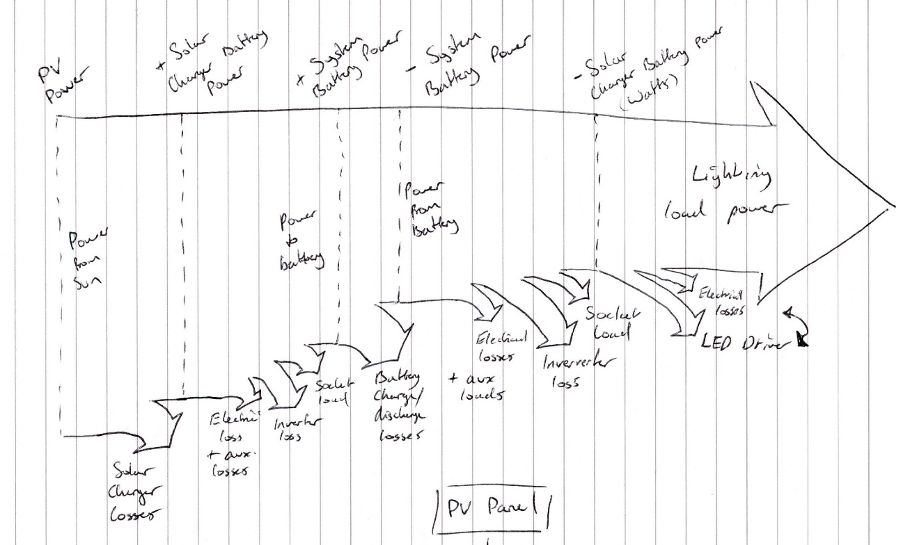
Fig X. Add nice sanky diagram?
2.3.1 The smart solar streetlight at Gihembe, Rwanda
It was proposed that a combination of regular and smart (consisting of ground-level AC sockets, programmable lights, remotely programmable control/access and data logging/communications) solar streetlights were deployed in Gihembe, with the locations being chosen with support of UNHCR, camp governance and the community (see Figure 1).
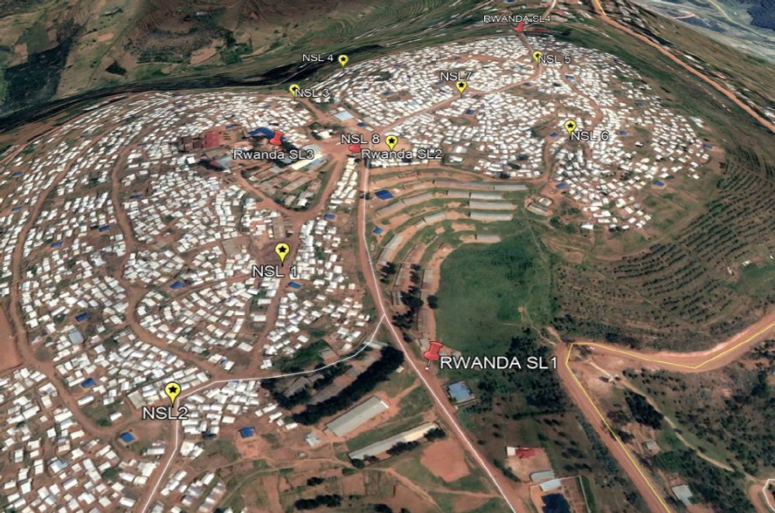
Figure 1: Map of Gihembe showing the 8 regular (yellow) and 4 smart (red) streetlight locations (need clearer image).
The xxx regular solar streetlights had a 60W LED light, 24V/200Ah lead acid battery storage and a 250 Wp PV panel. These streetlights were not equipped with monitoring equipment and are not reported on further in this paper. The smart streetlights with sockets were designed to have a slightly larger PV-battery configuration to power the monitoring equipment, reduce potential capacity shortages and enable larger socket load demands. The 4 smart streetlights had a 320 Wp Jinko solar panel, two 12.8V/120Ah li-ion batteries, 100/20 Victron solar charge controller, programmable 60 W light with ELG-75-C350D2 MEAN Well AC/DC LED Driver, Victron 24/180 Inverter (for the LED driver), Phoenix VE.Direct 12/250 (for the ground-level sockets), Victron Venus GX with GSM router for datalogging, Victron BMV 700 series battery monitor, Victron BatteryProtect 12/24V|65A, and ground-level double sockets with four additional USB ports. An overview of the system components is shown in Figure 2.

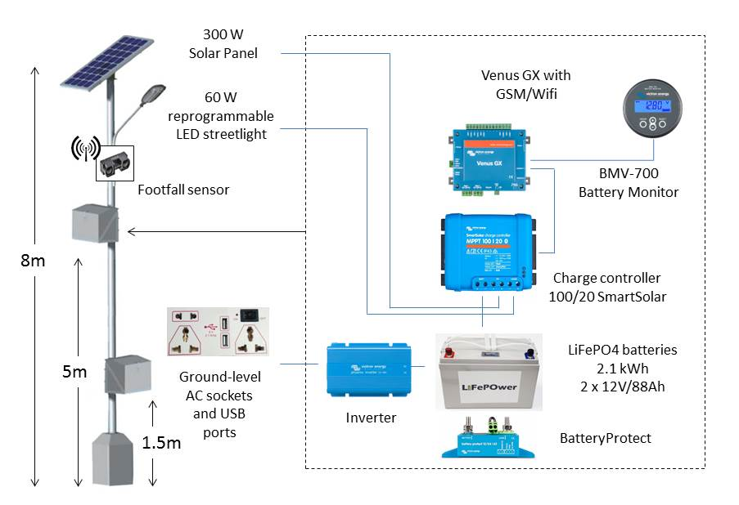

Inv.
Figure 2: Main component overview of the solar streetlight system (note that the second inverter for the light is not shown and need an update better schematic).
The specifications of the PV panels and the position of the PV panel on the four smart streetlight (SL1-4) are given in table 1.
Table 1: PV Panel data specification (location: 1°35'51.0"S 30°04'33.5"E)
Module efficiency under STCª | 16.49%
Peak power rating – Pmax (Wp): | 320
Solar cell type | Multicrystalline
Solar cell size | 156x156 mm
Module Dimensions | 1956 x 992 mm
Cell number | 72
Total array area (1 panel) | 1.94 m²
PV panel tilt angle | SL1:17°, SL2:18°, SL3:19°, SL4:18°
Orientation | North
ª STC condition：1000 W/m2,1.5AM and 25℃ cell temperature.

To encourage greater utilisation of the system and reduce solar energy capture losses during the day, an interface board was installed on site – located near the entrance to the camp – to show the community in real-time where surplus energy was available the streetlights (see figure 3).
(would it be better to put/show this in the discussion as something that is to be trailed once remedial actions at interventions have been taken, may be too much for this one paper?)
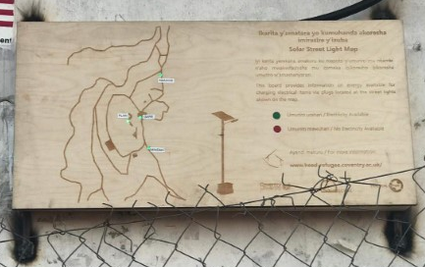
Figure 3: Streetlight energy availability interfance board

Installation work was carried out from May to June 2019, with launch event taking place in July 2019. The lights installed are shown in Figure 3.

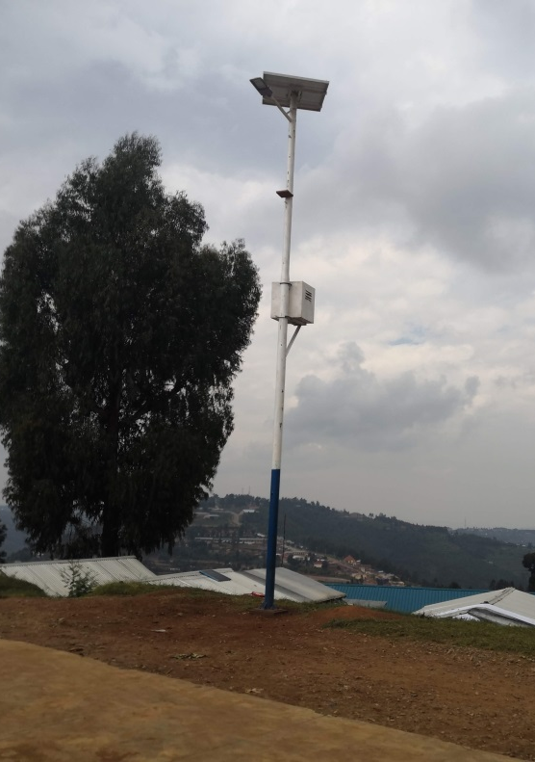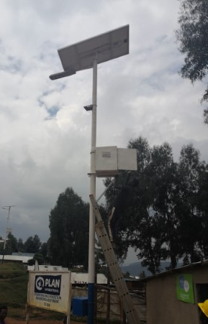
a
b
Figure 3a-b: A regular (a) and smart (b) solar streetlight installed at Gihembe, Rwanda.

2.3.2 The smart solar streetlight at Uttagaya, Nepal
Seven smart streetlights were sited at Uttargaya, on the locations chosen by the community (see Figure 5). The smart streetlights had two 150 Wp Sunworth PV panels, two 11.1V/88Ah li-ion batteries, Victron 100/20 solar charge controller, programmable 60 W LED light, Victron Venus GX for datalogging, Victron BMV 700 series battery monitor and ground-level sockets/USB ports powered by a 500 W Suoer DC-AC converter. An overview of the system components are shown in Figure 6.

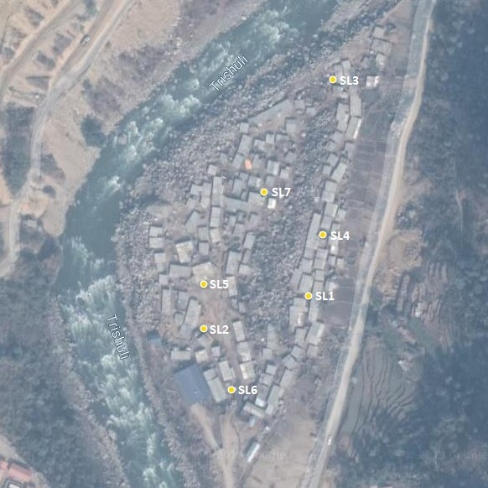
Figure 5: Map of Uttargaya showing the 7 streetlight locations (SL), labelled SL1 to SL7.

Figure 6: Main component overview of the solar streetlight system (redo)
The specifications of the Sunworth panels and the panel positioning for each streetlight are given in tables 2 and 3.

Table 2: Sunworth PV Panel data specification
Module efficiency under STCª | 15.2%
Peak power rating – Pmax (Wp): | 150
Solar cell type | Multicrystalline
Solar cell size | 156x156 mm
Module Dimensions | 1480 × 665 × 30 mm
Cell number | 36
Total array area (2 panels) | 1.968 m²
PV panel tilt angle | 27°
Orientation SL1-7 | 174°S; 143°SE; 143°SE; 170°S; 174°S; 176°S; 183°S
ª STC condition1000 W/m2,1.5AM and 25℃ cell temperature. Nominal operating cell temperature 46+/-2 degC at 800W/m2, AM 1.5, windspeed 1m/s, ambient temperature 20°C

The streetlight socket availability indictor dashboard installed at Nepal is shown in Figure 7.
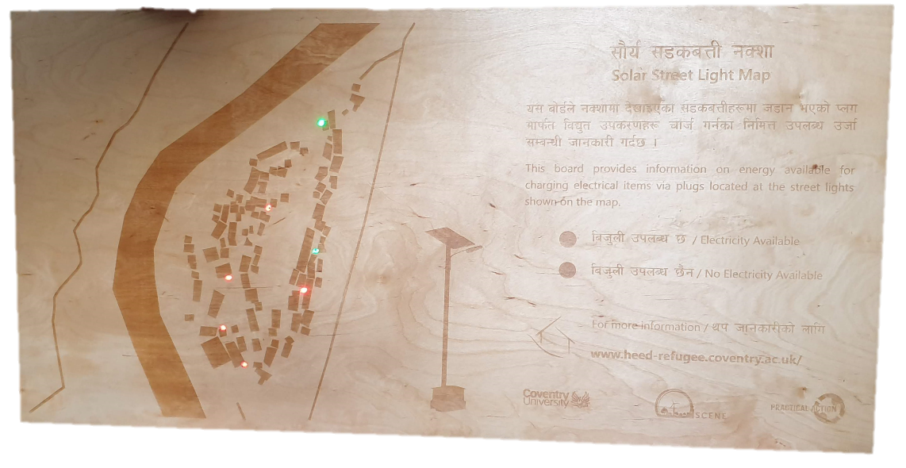
Figure 7: The solar streetlight map board before installation at Uttargaya.

Installation work was carried out from March to June 2019, with the commissioning and community opening events taking place in July 2019. The purpose of the community event was to introduce the community to the system, explain their functionality and inform them of how the interface board would notify them of the power availability at the streetlights.

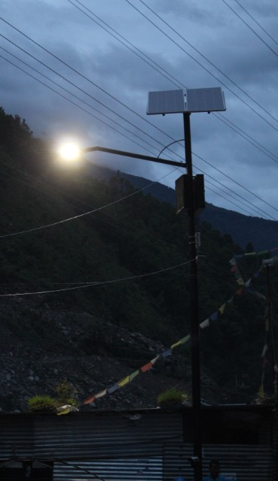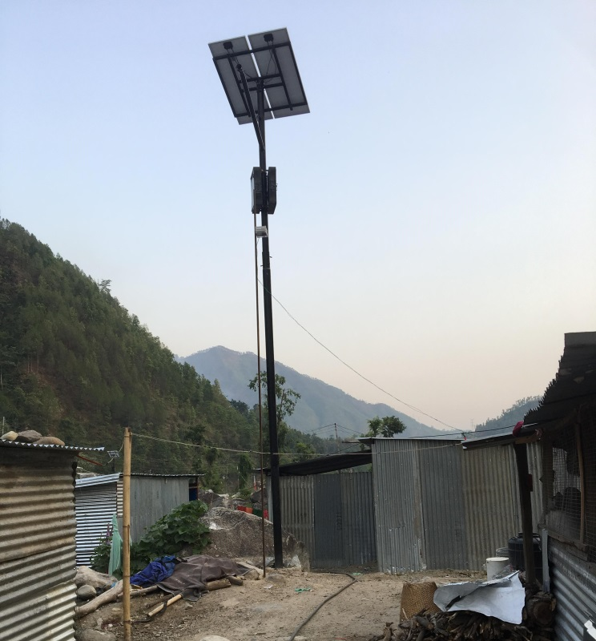
Figure 7: The installed solar streetlights at Uttargaya, Nepal.

2.4 Solar system performance measurements
Normalised system performance indices for daily mean yields, losses and efficiencies, were evaluated, aligned with the International Electrotechnical Commission Standard IEC 61724:(1998)/(2017) over the reporting period.
The array yield (Y_{A}), final yield (Y_{F}) and reference yield (Y_{R}) were calculated as:
$$Y_{A}= \frac{E_{A}}{P_{o}}$$ | (1)
$$Y_{F}= \frac{E_{Load}}{P_{o}}$$ | (2)
$$Y_{R}= \frac{A× ƞ_{STC}×\sum{Gi} }{P_{o}}$$ | (3)
where P_{o} is the peak power rating of the PV array, E_{A} is the daily PV energy output of the array, E_{Load} is the total load output of the system, A is the surface area of the PV array, ƞ_{STC} is the efficiency of the PV array at STC and Gi is the in-plane solar irradiance incident on the PV array.
The system capture losses, L_{C}, and system losses, L_{S}, are derived from the yields:
$$L_{C}=Y_{R}-Y_{A}$$ | (4)
$$L_{S}=Y_{A}-Y_{F}$$ | (5)
The performance ratio (PR), where PR=Y_{F}/Y_{R}, provides an indication of the overall losses in relation to the array’s rated output. This includes losses due to utilisation below the available irradiance, components inefficiencies, system failures and temperature variations. The production factor (PF) is also considered, where PF= Y_{A}/Y_{R}, as it easier to measure and identifies the system’s total utilisation of the potential array output (Ma et al., 2017).
The overall total system efficiency, η_{total}, is given by:
$$η_{total}= \frac{E_{Load}}{A×\sum{Gi}}$$ | (6)

2.5 Data collection and processing
- Reporting period
- Key variables and assumptions
- Data yield
- Data quality
- Data imputation and verification
The solar systems were monitored from July 2019 to X 2020. Live irradiance data from SolCast was used to estimate potential PV power output. Whilst using a pyranometer is recommended for obtaining local solar irradiance measurements for utility-scale PV system performance assessment, satellite-obtained solar irradiance data is often used to assess smaller systems (typically less than 5 kWp) (Copper et al., 2013). The accuracy of satellite-measured irradiance data, has been researched in several studies, finding root mean square errors to be low at 3.4% for clear conditions, but increasing to above 25% for clouded skies (Perez et al., 2001,Bright, 2019).
The total load output was calculated from the combined light and socket consumption. In Rwanda the AC socket load output was provided to the Venus GX by the VE inverter, whereas in Nepal the socket load was inferred from the solar charger and battery power readings. In Nepal, the light load was provided by the solar charger’s DC load output reading; however, in Rwanda it had to be estimated from the battery data, with the system and inverter efficiency being around 77%. Or taken as the load demand met by from the charger controller and batteries, and therefore include the inverter losses. Thus the system losses are for the solar charger and battery losses only.?
The key parameters used in the analysis are sumarised in Table X.
Table X:
Parameter | Units | Description
Irradiance on PV panels | (kWh/m²/day) | In-plane irradiance on PV panelsª
Potential PV power out | (kWh_{el}) | Potential PV power output based on irradiance profile under STC
Actual PV power (E_{A}) | (kWh_{el}) | Power output from PV panels^{b}
Battery charge power | (kWh) | Power delivered to batteries from PV panels^{b}
Battery discharge power | (kWh) | Power drawn from batteries^{b}
Total load output (Eload) | (kWh_{el}) | Total light and socket consumption^{b}
Final yield (Y_{f}) | (kWh/kWp/day) | Ratio of utilised PV yield to the peak power of the installed PV array
Reference yield (Y_{r}) | (kWh/kWp/day) | Potential in-plane solar irradiance on PV array
Actual array yield (Y_{A}) | (kWh/kWp/day) | Actual power delivered from PV panels
System losses (Ls) | (kWh_{el}) | Difference between actual PV output and utilised PV yield
PV capture losses (Lc) | (kWh_{el}) | Difference between potential PV output and actual PV power
Performance ratio (PR) | (%) | Ratio of final yield to reference yield
Production factor (PF) | (%) | Ratio of actual array yield to reference yield
Total system efficiency (ηtotal) | (%) | Ratio of consumed energy to potential PV yield
ª Irradiance on PV panels calculated from live global horizontal irradiance (Ghi) values obtained from SolCAST
^{b} Obtained from Venus GX data

Missing data will occur in PV systems for several reasons (e.g. power outages, communication issues and component faults). Strategies for dealing with missing data can add a high degree of uncertainty to performance assessments (Koubli et al., 2016). The number of readings from the Venus GX for the solar charger and battery power values every hour from each streetlight in Rwanda and Nepal are shown in Figures X and X.
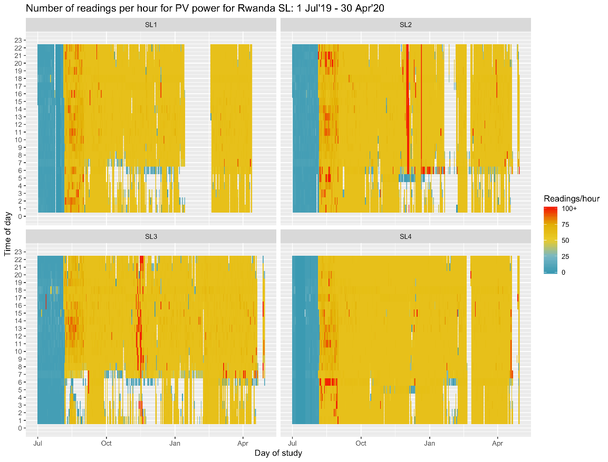
Fig.Xa-d. Hourly yield of data (produce same graphs for Nepal Lights, don’t go beyond March end?) from Rwanda streetlights 1-4.
Fig Xa-d shows that missing data from the streetlights in Rwanda frequently occurred between 12 pm -6 a.m., which was characteristic of a power outage. This was also backed up by in-field observations. This was most prevalent at streetlight 3 (X%?), but uncommon at Streetlight 4 (X%?). The data yield was the same for all variables described in Table X, apart from the socket load output readings which slightly lower (See Appendix). The frequency of data collection was increased at the start of August.
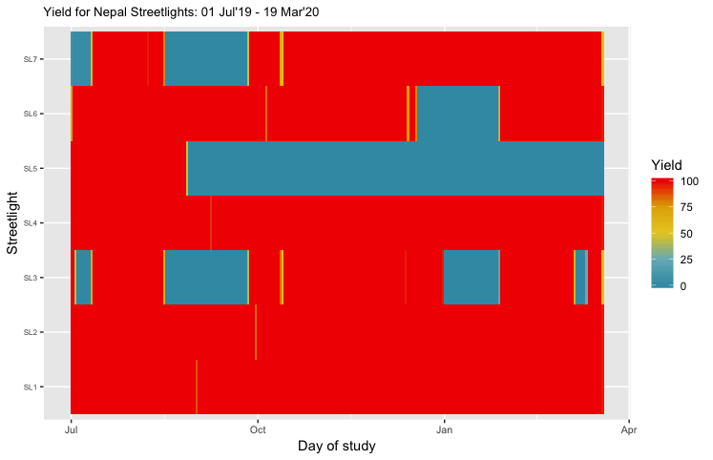
Fig.X: Percentage hours for which data is available per day ().

Sentence or 2 on % yields. The large sections of missing data in Nepal were attributed to communication issues.
To accurately model the performance of PV systems over a long period, data imputation is required to avoid inaccuracies [ref]. Literature on forecasting or back filling data in PV systems have mainly focused on determining irradiance and temperature data for grid connected systems (Raza et al., 2016,Almeida et al., 2015) (Sundararajan and Sarwat, 2019)(Koubli et al., 2016). These studies showed that X and random forest are well suited for forcasting and handling missing data in PV systems, because…
In off-grid applications, the actual PV power generation also depends on the battery SoC and load demand; if there is no demand the PV power output in limited by the charge controller, which results in capture losses. So we also do/use… what?
Frequent spikes, erroneous data and missing data in PV systems increases the error of forecasting techniques, but it will also increase errors when backfilling data. Therefore, if the yield for a particular month is below X amount, we do not backfill.
Erroneous data/Outliers [(for which variables) occurred because (..)] and were removed using the 67-95-99 rule reducing yield further from X% to X%.
Or we could base it on certain criteria:?
- Could remove irradiance data for day, if actual PV power output exceeded SolCast prediction…? But who is to say the PV power output is correct… Assuming SolCast is wrong seems reasonable given its inaccuracy for cloudy days. At the moment, I would not do this.
- Adverse situations such as onsite testing/maintenance? Too hard to track, given we had so many and poor communication at times.
… or do we just have a data processing tool that are robust to outliers…
Socket inverter reading had lower yield (does this need a new heat map…?).
Missing data/time series is back filled…. (How?) kNN/Forest
Testing/evaluation of method - uncertainty analysis?
Nepal Streetlight 5 removed due to low data yield and faulty Venus GX? Do we keep SL7 even though doesn’t work, because that is what we are looking at?
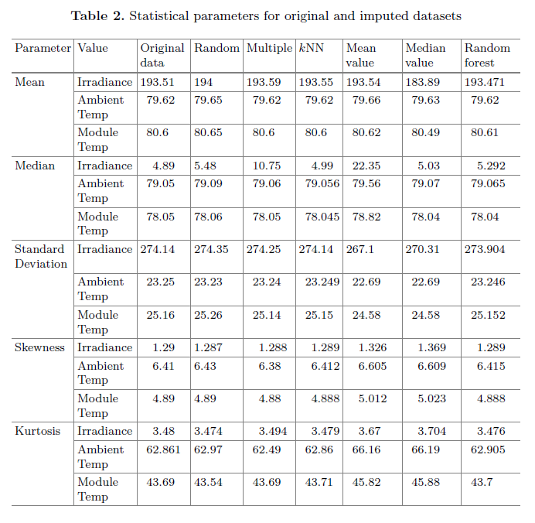
Can we do something like this to justify out chosen method for a test period where we actually have data see (Sundararajan and Sarwat, 2019). But our parameters are, Actual PV power, battery SoC, battery charge/discharge, light load and socket load (or total load), capture losses and capacity shortage. Maybe getting on to an entirely new paper…
Results are taken up to the end of March (because of COVID?) Otherwise: Do we need to justify the cut period?
Significant changes during data collection period should be reported. Give a sense of the severity of the pandemic (including health, social and economic impacts, as relevant). Use official government references for a description of such policies where possible, in ways that are cognizant of their rapid temporal evolution. Did camp comes under “a high-risk category” and observe stricter measures? What other variables may have changed energy demands? Hard to access concerns and true impact of the pandemic on energy research?
file:///C:/Users/ac2569/Downloads/PREPRINT%20version%20COVID%20validity%20paper.pdf

- Results
- Typical day profiles for seasons/months/predicted/actual
- Monthly values tabulated for consumption and losses for each streetlight
- Monthly system efficiencies
- Potential for growth in usage
The measured performance of the two streetlight interventions in Rwanda and Nepal are provided and compared with the anticipated performance. The technical, social and environmental causes for divergence in performance are evaluated. Potential actions required to improve the performance of the streetlights are identified, and the subsequent patterns of socket usage that would maximise the system utilisation and performance are examined. The two case studies are then summarised and discussed to provide answers to the three research questions outlined in the introduction.

  - Rwanda streetlight performance
Typical day profiles show when divergence from expected consumption occurred, and the influence this has on SoC (need to find a way to model and reference due to faulty BMV config) and actual PV power, which is limited when the battery is fully charged.

Fig Xa-b: Actual and predicted typical day performance profile (Rwanda). Add typical day performance profile between Jul-Mar – average of all 4 lights
The monthly daily averages for expected and actual consumption and the resulting capture losses for each solar streetlight in Rwanda. The average performance ratio and production factor for the four lights for each month are shown in fig X.
- PV potential less than predicted to do PV panel azimuth south misalignments
- Total load approx. half what was expected due to low socket usage and poor LED light reliability
- System losses (battery and solar charger) slightly higher than expected due to under predicted battery and solar charger efficiencies
- No capacity shortage detected due to system outages – predicted was 1.72%
- Actual average production factor so far is 44%, predicted annual average was 64%.
- If the lights had been set to have no dimming, the predicted annual production factor was 72% with a capacity shortage of 3.7%.

Fig X. Actual and expected performance of Rwanda Streetlights (add all 4 lights). Add Socket Load, Light load, System losses and auxiliary loads, Capture Loss.

Fig X: The key performance indicators for Rwanda (based on average of 1-4), PR,PF and total efficiency. The potential PV power and total load is shown on secondary axis.
The technical, social and environmental influences for divergences between anticipated and actual performance and utilisation of the streetlights are summarised in table X.

Table X: (Rwanda)
 | Design and performance | Execution and maintenance | Human interaction and utilisation | Environment
Rwanda | Change from DC to AC light result in higher than expected power demand due to inverter and driver inefficiencies  Frequent power outages | Lack of knowledge and skill with using imported components.  Faulty SoC readings due to BMV configuration  Non-standard wiring and loose connections  System and component voltage mismatches for inverter and LED driver requiring additional converters | Community concerned with leaving devices at socket boxes due to water ingress and potential theft | Heavy rain fall resulted in water getting into socket boxes  Bee hives in battery box

The changes proposed for the Rwanda streetlights were replacement LED drivers and changing from a 12/250 to 24/250 VE inverters for the sockets. This would improve the light load efficiency by around 25% and improve system reliability by removing additional DC-DC converter. Based on these system changes, Fix X shows how the surplus energy available from the socket would vary each day over an entire TMY/analysis period, taking into account inefficiencies (88% inverter, system losses?) and capture losses. 75%/90% of time there would be X kWh available per day, with a peak of X kW.

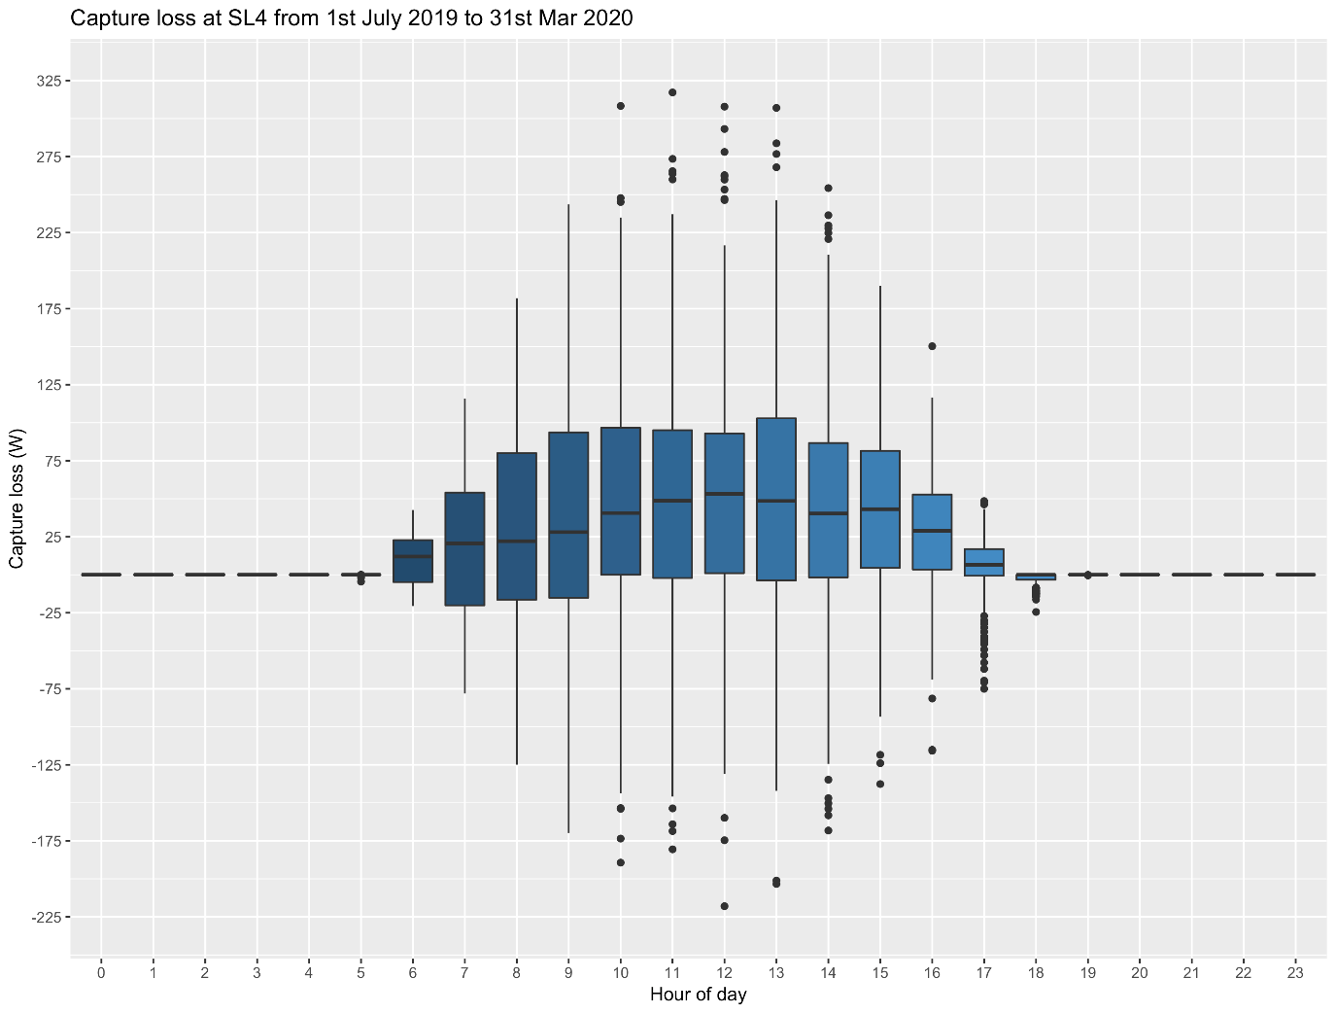
Fig X: Additional energy that could be utilised from the system, after remedial action to improve system performance. how will this look with predicted irradiance or TMY data,. rather than live solcast? (Rwanda)

3.2 Nepal Rwanda streetlight performance
Add typical day performance profile between Jul-Mar. (average of 1,2,3,4,6?)
These results show…

Fig Xa-b: Actual and predict typical day performance profile.
The monthly daily averages for expected and actual consumption and the resulting capture losses for each solar streetlight in Nepal. The average performance ratio and production factor from the lights for each month are shown in fig X.
- PV potential less than predicted to do PV panel azimuth south misalignments
- Total load approx. half what was expected due to low socket usage and poor LED light reliability
- System losses (battery and solar charger) slightly higher than expected due to under predicted battery and solar charger efficiencies
- No capacity shortage detected due to system outages – predicted was 1.72%
- Actual average production factor so far is 44%, predicted annual average was 64%. Our KPI was 60% if you remember.
- If the lights had been set to have no dimming, the predicted annual production factor was 72% with a capacity shortage of 3.7%. The monsoon in Nepal makes it harder to have a better production factor without reducing reliability too much.

Fig X. Actual and expected performance of Nepal Streetlights (add 1,2,3,4,6).

Fig X: The key performance indicators for (based on average of 1-4), PR,PF and total efficiency. The potential PV power and total load is shown on secondary axis. Nepal. (Actual performance would be even lower if SL7 is included.
The technical, social and environmental influences for divergences between anticipated and actual performance and utilisation of the streetlights are summarised in table X.

Table X:
 | Design and performance | Execution and maintenance | Human interaction and utilisation | Environment
Nepal | Low production factor (30-55%) due unreliable custom LED light/driver and lower than expect socket usage  Difficulties with detecting low loads at socket usage  Faulty Venus GX in SL5  Unreliable inverters: needed frequent restarts and replacements | No Ingress Protection (IP) standard used for weather proofing.  Lack of knowledge and skill with using imported components.  Unreliable custom components used for LED light and driver  PV off-axis panel installations  Excessive installation time that took many months | Online and telephone communication difficulties between team with contractors and community.  Community’s desire for surplus energy access at sockets not realised in practice.  Usage limited to mobile phone charging (mostly teens/young adults?) and nearby in-home lighting  Minimal demand for AC socket usage due to most household having access to the grid from bulk/sub meters  Socket connections were often damaged and not cared for  As the lights were unreliable, the community feared this was due to the usage of the sockets. | Heavy rain fall resulted in water getting into both battery and socket boxes  Community reported lightning strikes as a possible cause for system failures following a storm  High wind’s damaged homes and wifi systems (?)  No mobile network coverage, and wifi was unreliable

The changes proposed for the Nepal streetlights are replacement of the LED light driver and changing to a 12/250 VE inverter for the sockets. This is to improve the reliability of both the light and socket inverter. Based on these system changes, Fix X shows how the surplus energy available from the socket would vary each day over an entire TMY, taking into account inefficiencies (88% inverter, system losses?) and capture losses. 75%/90% of time there would be X kWh available per day, with a peak of X kW.

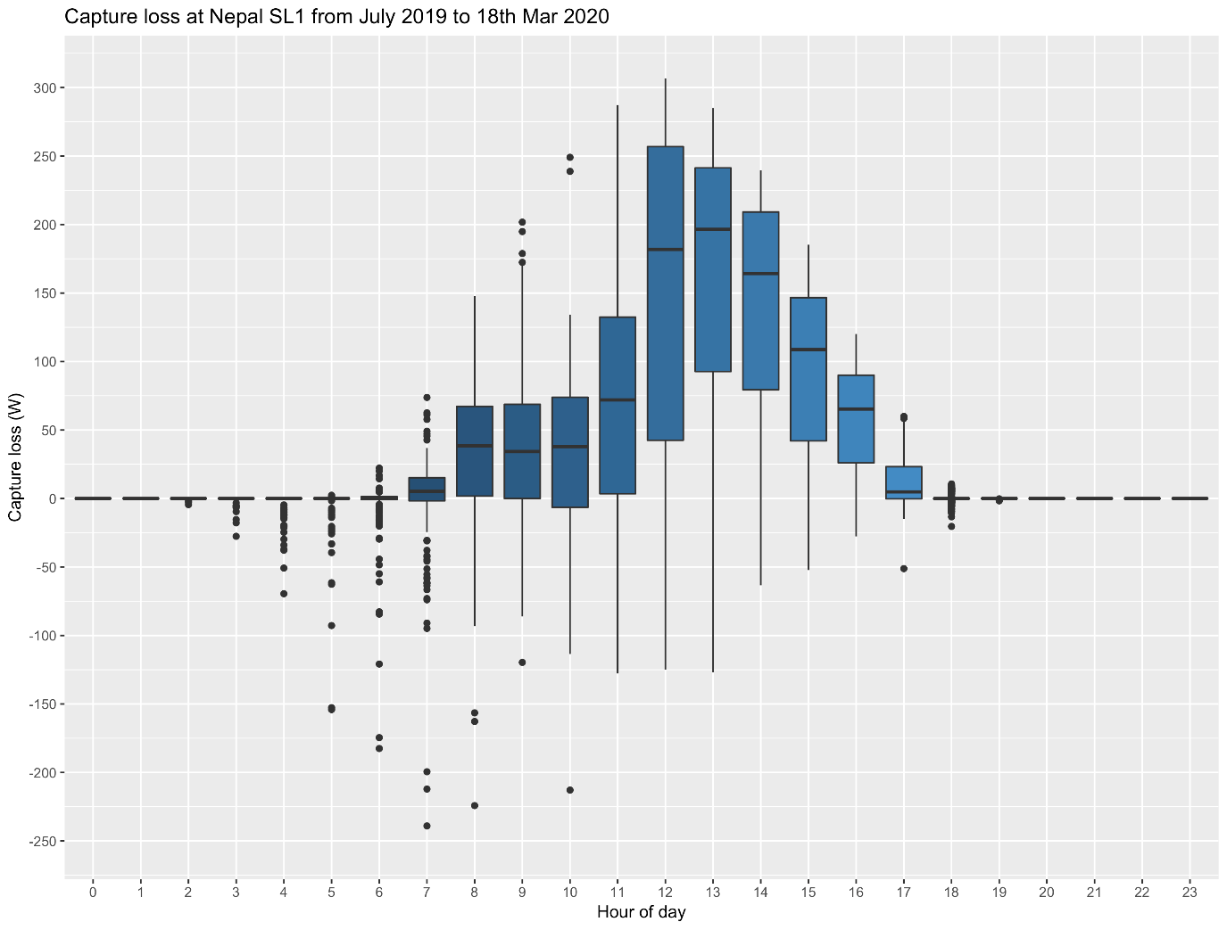
Fig X: Additional energy that could be utilised from the system, after remedial action made in Nepal. how will this look with predicted irradiance or TMY data,. rather than live solcast, which often over/under predicts the actual irradiance during cloudy conditions?

- Discussion
- How do are results compare with other reported off-grid streetlights?
- What are the implications of the results in a humanitarian setting?
- What were caused for unexpected poor performance: quality of components, access to sites, supplier inexperience with forgien products.
- Further work/research question that need to be answered
Q1: What can be learnt from deploying solar streetlights in displaced settlement that will make future interventions more technically successful?
- An interesting observation was that the poor performance of the systems was not due to tampering, damage or component theft. This is often cited as a major cause. A lot of effort went into the community engagement and co-design process, which may have mitigated this risk.
- Supplier experience, local skills, access to parts.
- In Rwanda, even the poles had to be imported from Uganda which caused significant delays in deployment. Impart problems caused delays in Nepal too.
- Build and test 1 system, revise/improve before upscale.
- Ascertain energy demands for communal resource first – battery/invert/socket box example?
- Similarities between Nepal and Rwanda: (low socket usage, issues with LED driver/lights, supplier lack of experience with system outside of the norm, community looked after systems well and engaged with team, poor quality workmanship?)
- Pyrometer needed for more accurate performance assessments, even though this is not necessary recommended for such small scale solar systems, as day-to-day error for actual PV power output to live SolCast data ranged from –X% to X% (which was unexpected based on the 25% error report in (Perez et al., 2001,Bright, 2019), +differences could be due to panel alignment error measurements and shading
- If monitoring and collecting data in field for any PV system, there is a need to evaluate properly any missing data, which has not be done in the majority PV assessment studies. Need to analyses yield and when data is missing, to aid in determining why missing data is occurring – using only full data days [such as in gives ref] could result in inaccuracies as battery behaviour is cyclic and power outages have to be taken into consideration to be able to properly estimate capture losses and capacity shortage. Difficulty of imputing data accurately for large amounts of missing and erroneous data.
Q2: Can solar streetlight performance be improved by providing communities with access to surplus energy at the lights and does demand exceed supply?
- No indication from results that a centralised system providing community energy access and powering the streetlights would be of any benefit as socket appliance rarely exceeded rated capacity. (Nepal site was small, so would probably have been more cost effective. Rwanda lights spread over wide area, so would become impractical.)
- Whilst usage was low, usage of sockets in Rwanda was particularly important to youths as it enabled them to charge their phones, save money from pay other vendors for phone charging and staying informed/connected. Similar usage of the socket in Nepal was mostly by youths, other than streetlights near homes which could connect indoor lights (not even mentioned logbooks yet to explain how we know this…)
- Need more intelligent control of the light load and brightness based on state of charge and day ahead forcasts, however internet access to local parts to enable this makes this difficult.

Q3: How accurate were the assumptions and simulations to design and size the systems using energy demand assumptions and meteorological conditions? What were causes for divergence (Do we want a similar question to the other solar paper 5?)

- SolCast inaccuracy (often lower than actual PV power output…) More reliable SolCast data for Nepal – why, can we quantify?
- The assumption made did not take into account unreliable components (an issue in Nepal due to the quality of the inverter and LED light/driver) or availability and selection of appropriate parts, such as AC/DC driver mismatch and inverter voltage rating mismatch (a DC-DC converter was used to make the 12 Voltage Inverter for the Socket match the system voltage, which likely caused some of the reliability issues)
- Power outages at Rwanda; low loads due to light in Nepal.

5. Conclusion
- Critical reflection on the extent to which the aim/objectives/ RQ where addressed
Acknowledgements
The authors would like to acknowledge the financial support under the Humanitarian Engineering and Energy for Displacement (HEED) project financed by Research Councils UK (EP/P029531/1), along with the contributions from project partners at Practical Action and support of MIDIMAR and UNHCR.

Reference
Photovoltaic system performance monitoring — Guidelines for measurement, data exchange and analysis (IEC 61724:1998). , 1998.
Almeida, M.P., Perpinan, O., Narvarte, L., 2015. PV power forecast using a nonparametric PV model. Solar Energy 115, 354-368.
Bellanca, R., 2014. Sustainable Energy Provision among Displaced Populations: Policy and Practice. Chatham House, The Royal Institute of International Affairs.
Bright, J.M., 2019. Solcast: Validation of a satellite-derived solar irradiance dataset. Solar Energy 189, 435-449.
Copper, J., Bruce, A., Spooner, T., Calais, M., Pryor, T., Watt, M., 2013. Australian Technical Guidelines for Monitoring and Analysing Photovoltaic Systems. The Australian Photovoltaic Institute (APVI),(Version 1) , 7.
Fashina, A.A., Azeko, S.T., Asare, J., Ani, C.J., Anye, V.C., Rwenyagila, E.R., Dandogbesi, B., Oladele, O., Dyeris, M., 2017. A study on the reliability and performance of solar powered street lighting systems. Int.J.Sci.World 7, 110-118.
Gaura, E., 2019. Humanitarian Engineering and Energy for Displacement (HEED) dataset (EP/P029531/1), available at: http://data-portal-heed.s3-website.eu-west-2.amazonaws.com/.
International Electrotechnical Commission, 2017. Photovoltaic system performance Part 1: Monitoring (IEC 61724-1.0, 2017-03). IEC, Geneva, Switzerland .
Kama, A., Diallo, M., Drame, M.S., Ndiaye, M.L., Ndiaye, A., Ndiaye, P.A., 2017. Monitoring the performance of solar street lights in Sahelian environment: case study of Senegal. , 56-61.
Koubli, E., Palmer, D., Rowley, P., Gottschalg, R., 2016. Inference of missing data in photovoltaic monitoring datasets. IET Renewable Power Generation 10, 434-439.
Lagorse, J., Paire, D., Miraoui, A., 2009. Sizing optimization of a stand-alone street lighting system powered by a hybrid system using fuel cell, PV and battery. Renewable Energy 34, 683-691.
Ma, T., Yang, H., Lu, L., 2017. Long term performance analysis of a standalone photovoltaic system under real conditions. Appl. Energy 201, 320-331.
McMorran, B.J., Adami-Sampson, N.D., Bachman, N.C., 2016. Investigating Solar Street Lights in Mandi and Kamand.
Millinger, M., Mårlind, T., Ahlgren, E.O., 2012. Evaluation of Indian rural solar electrification: A case study in Chhattisgarh. Energy for Sustainable Development 16, 486-492.
Nyemba, W.R., Chinguwa, S., Mushanguri, I., Mbohwa, C., 2019. Optimization of the design and manufacture of a solar-wind hybrid street light. Procedia Manufacturing 35, 285-290.
OLADEJI, A., SULE, B., BALOGUN, O., 2015. TECHNO-ECONOMIC AND ENVIRONMENTAL FEASIBILITY STUDY OF USING SOLAR LED STREETLIGHT IN NIGERIA: A CASE IN THE CITY OF ILORIN KWARA STATE.
Panguloori, R., Mishra, P., Kumar, S., 2013. Power distribution architectures to improve system efficiency of centralized medium scale PV street lighting system. Solar Energy 97, 405-413.
Perez, R., Kmiecik, M., Herig, C., Renné, D., 2001. Remote monitoring of PV performance using geostationary satellites. Solar Energy 71, 255-261.
Raza, M.Q., Nadarajah, M., Ekanayake, C., 2016. On recent advances in PV output power forecast. Solar Energy 136, 125-144.
Sundararajan, A., Sarwat, A.I., 2019. Evaluation of missing data imputation methods for an enhanced distributed PV generation prediction. , 590-609.
Tannous, S., Manneh, R., Harajli, H., El Zakhem, H., 2018. Comparative cradle-to-grave life cycle assessment of traditional grid-connected and solar stand-alone street light systems: A case study for rural areas in Lebanon. J. Clean. Prod. 186, 963-977.

Appendix A
To size the smart streetlight systems a number of assumptions were made to establish a potential energy profile so that components could be appropriately chosen. The assumption made was that the system needed to provide at least 0.78 kWh/d with a peak load of 0.7 kW. This was based on a 60W LED light at full brightness from 6pm – 12 am, and at half brightness from 12am-6 am, and an auxiliary load of 10 watts throughout the day. For the ground-level socket demand, 0.3 kWh/day with a peak load of 0.14 kW was assumed, with peak demand occurring at midday. The assumed energy demand profiles are shown in Figure 2.

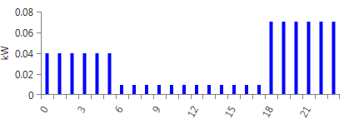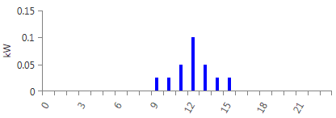
Figure 2: Assumed daily load profile for streetlight (left) with socket loads during the day (right).
Irradiance values taken from the TMY data from National Solar Labs.
Component | Assumptions
PV Panels | Wp, eff., orientation, tilt
Solar charge controller | MPPT, size, eff.
Converter | Rating, eff.
Battery | Ratting ,eff.
Socket load | Total/day
Light load | Total/day

A number of simulations were carried out using HomerPro. A day-to-day and timestep variability of 10% was assumed for the socket load demand. The PV panels were assumed to be north facing with a latitude slope angle of 28 deg. Based on meteorological data for Rasuwa, Nepal (see Table 1), using 300 W PV and 2 kWh of li-ion batteries would results in an expected capacity shortage of 5.4%. Excess electricity (wastage) would be 95.2 kWh/year (18.9%) with a PV yield of 503 kWh/yr and total consumption of 377 kWh/y. Figure 3 delineates the micro-grid concept as a schematic.

Table 1: Monthly average solar global horizontal irradiance (GHI) data for Kigeme, Rwanda, according to the National Renewable Energy Lab database.
Month | Jan | Feb | Mar | Apr | May | Jun | Jul | Aug | Sep | Oct | Nov | Dec
Clearness Index | 0.478 | 0.471 | 0.452 | 0.431 | 0.436 | 0.531 | 0.554 | 0.503 | 0.473 | 0.454 | 0.44 | 0.467
Daily Radiation (kWh/m²/day) | 4.885 | 4.94 | 4.759 | 4.363 | 4.144 | 4.849 | 5.138 | 4.937 | 4.872 | 4.732 | 4.506 | 4.714

PV Panel
320 W
Li-ion battery
3 kWh
DC
Light
0.78 kWh/day
Sockets
0.3 kWh/day
AC
Converter
0.2 kW
Figure 3: Concept schematic for the advanced solar streetlight

Table 1: Monthly average solar global horizontal irradiance (GHI) data for Rasuwa, Nepal, according to the National Renewable Energy Lab database.
Month | Jan | Feb | Mar | Apr | May | Jun | Jul | Aug | Sep | Oct | Nov | Dec
Clearness Index | 0.662 | 0.630 | 0.655 | 0.668 | 0.618 | 0.502 | 0.424 | 0.412 | 0.501 | 0.666 | 0.691 | 0.641
Daily Radiation (kWh/m²/day) | 4.113 | 4.669 | 5.855 | 6.879 | 6.879 | 5.703 | 4.741 | 4.350 | 4.701 | 5.224 | 4.467 | 3.739

PV Panel
300 W
Li-ion battery
2 kWh
DC
Light
0.78 kWh/day
Sockets
0.3 kWh/day
AC
Converter
0.2 kW
Figure 3: Concept schematic for the advanced solar streetlight.

Appendix B
The following product requirements were subsequently drafted, and a call to suppliers was sent out in January 2019 requesting proposals and quotes for the advanced streetlight concept.

- A PV-battery system street light capable of powering a 60W LED streetlight from dusk to dawn with a greater than 95% reliability.
- Light powered from dusk to dawn with the ability to automatically dim when battery charge is low; when lit, light should be at full power for at least 95% of the year.
- A fully reprogrammable MPPT solar charger controller
- Optional motion sensor and timer for on/off load built into the charge controller.
- Ground level access to surplus energy from the battery/PV panel, including 2 AC universal or 2-pin sockets, 4 USB charging points located in a lockable metal/weather proof box; the box needs to have sufficient space to locate additional equipment (e.g. phones, plugs, cables).
- Lighting load needs to be prioritised to ensure the light is always powered; non-essential loads need to be disconnected when there is no longer sufficient surplus energy.
- Surplus energy availability displayed within the storage box.
- Light and system load: 0.78 kWh/d 0.07 kW peak; external load expected approx. 0.3 kWh/d, 0.14 kW peak.
- Data sent wirelessly and logged to local memory (e.g. an SD card) for PV output, solar time, battery state of charge, battery charge rate, light on/off status, total socket/USB load and light load.
- Supporting frame structure to last a minimum of 20 years without suffering significant damage or corrosion.
- Safely secured PV and battery system (to streetlight structure) located at the top of the structure to minimise risk of theft.
- Light located 7-9 m above ground.
- Battery to have IEC 61427 and IEC 60896-21/22 certification
- Solar panels must comply with IEC 61215 standards (second edition)
- Circuit breakers and surge protection devices and earthing/lightning protection where applicable
- 5 year limited warranty on all components, with the exception of batteries which are to have a 2 year limited warranty
 | Design and performance | Execution and maintenance | Human interaction and utilisation | Environment
Nepal | Low production factor (30-55%) due unreliable lights and lower than expect socket usage.  Difficulties with detecting low loads at socket usage  Faulty Venus GX in SL5 | No Ingress Protection (IP) standard used for weather proofing.  Lack of knowledge and skill with using imported components.  Unreliable custom components used for LED light and driver  PV off-axis panel installations  Excessive installation time that took many months. | Community’s desire for surplus energy access at sockets not realised in practice.  Usage limited to mobile phone charging (mostly teens/young adults?)  Minimal demand for AC socket usage due to most household having access to the grid from bulk/sub meters | Heavy rain fall resulted in water getting into both battery and socket boxes  Community report lightning strikes as a possible cause for system failure following a storm  High wind’s damaged homes and wifi systems (?)  No network coverage, and wifi was unreliable
Rwanda | Change from DC to AC light result in higher than expected power demand due to inverter and driver inefficiencies  Frequent power outages | Lack of knowledge and skill with using imported components.  Faulty SoC readings due to BMV configuration  Non-standard wiring and loose connections | Community concerned with leaving devices at socket boxes. | Heavy rain fall resulted in water getting into socket boxes  Bee hives in battery box

Yield for Socket Load in Rwanda
